Lab 11: Blind SQL injection - Error SQL Injection
Objective:
- This lab focuses on Error-Based SQL Injection, a method where attackers induce database errors to gather information about the database structure and contents. Participants will work with a simulated web application that is deliberately configured with error-based SQL injection vulnerabilities.
In this lab, students need to:
- Answer the following questions:
  - What is an Error-Based SQL Injection attack, and how does it differ from other types of SQL injection?
  - Explain the concept of using database errors to extract information, and describe the typical signs that a web application might be vulnerable to this type of attack.
- Perform challenge:
  - Blind SQL injection with conditional errors
- Explain and capture all steps (full windows screen capture).

Group Members:
- Phạm Hoàng Hải Nguyên (SE180511)
- Nguyễn Trúc Quỳnh (SE180280)
- Giã Thị Nhã Trân (SE180405)

Submit a report addressing all the questions mentioned above in either PDF or Markdown format. Additionally, include a video demonstrating the detailed process of your work to ensure the authenticity of your lab exercise.
The report file name must be Class_YourStudentID _YourName_Lab11

Blind SQL injection with conditional errors
The request is intercepted and analyzed using Burp Suite Community Edition while accessing the lab from PortSwigger. The HTTP response reveals a TrackingId cookie, which is later used as the injection point to test and exploit a Blind SQL Injection with conditional errors vulnerability.
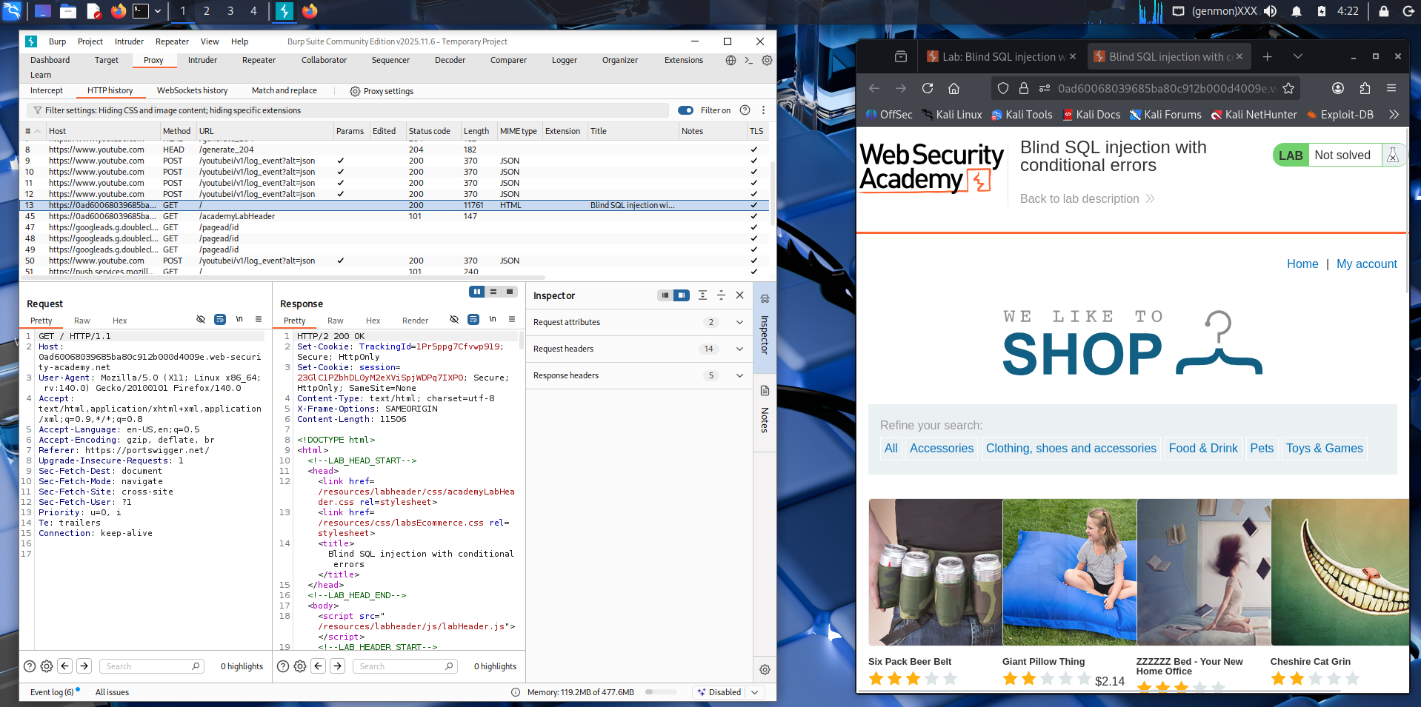

The request was modified in Burp Repeater by injecting a SQL payload into the TrackingId cookie parameter. When the request was sent, the server returned an HTTP 500 Internal Server Error, indicating that the injected SQL condition triggered a database error. This behavior confirms that the application processes the input within a SQL query and is vulnerable to Blind SQL Injection with conditional errors.
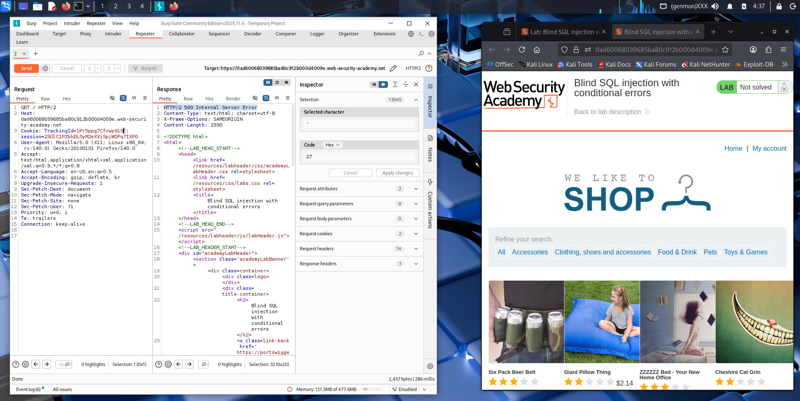

The injected SQL condition was modified and the request was sent again using Burp Suite Community Edition. This time the server returned HTTP 200 OK, meaning the error was not triggered. By comparing responses (500 vs 200), it is possible to determine whether a tested condition is true or false during the Blind SQL Injection with conditional errors process.
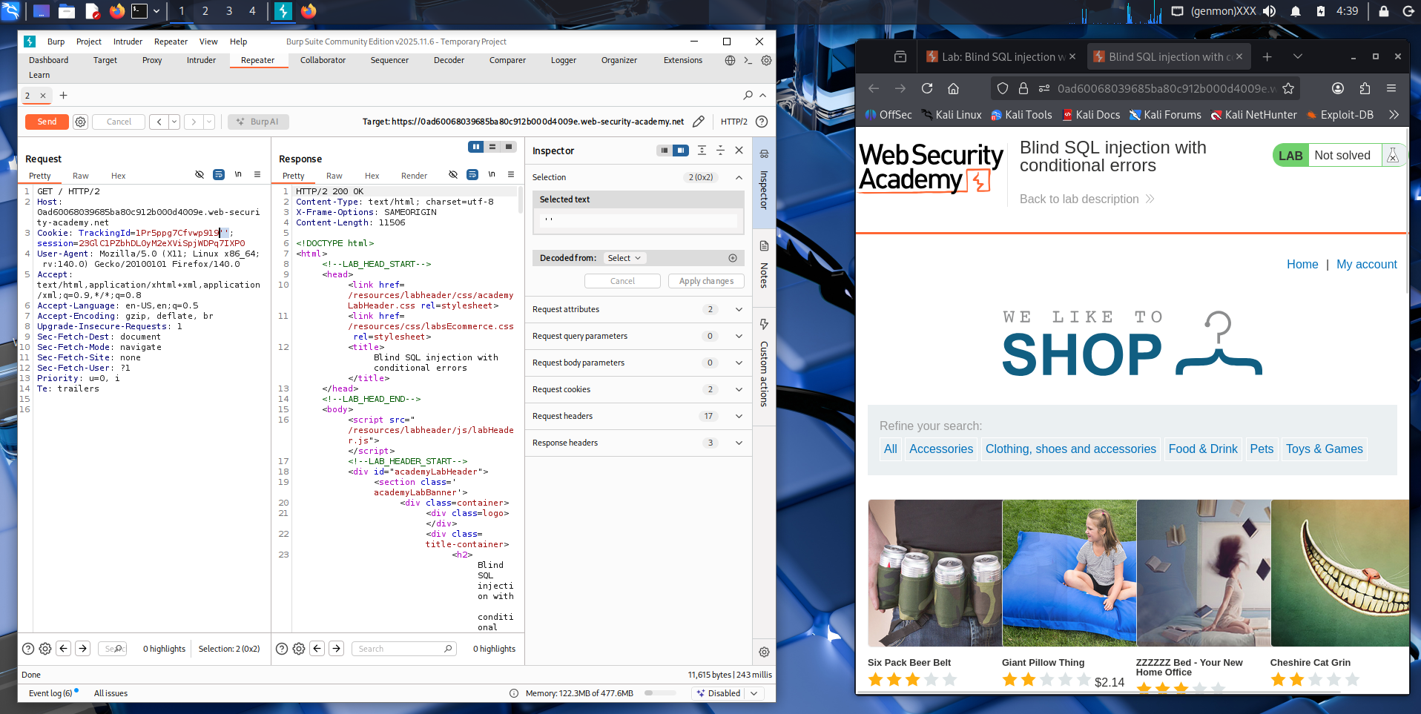

The injected SQL query is added into the TrackingId cookie using Burp Repeater. The payload attempts to query the users table to test whether the application processes the injected condition.
The server returns a normal HTTP 200 response, indicating the query executes without causing an error. This behavior helps determine whether the condition in the injected SQL statement evaluates to true during the blind SQL injection test.
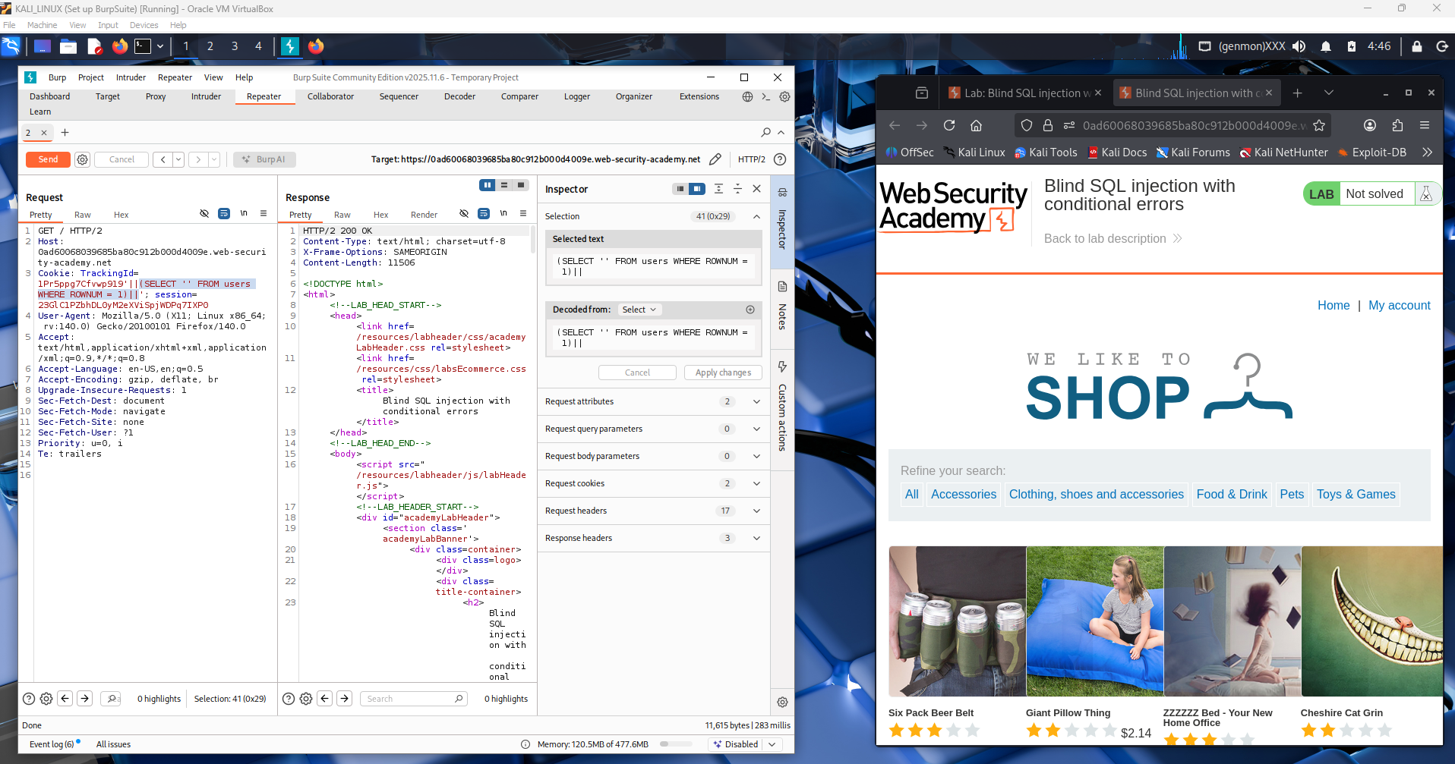

In this step, Burp Suite Repeater is used to manually test a Blind SQL Injection with conditional errors on a lab from Web Security Academy.
The tester modifies the TrackingId cookie and inserts a SQL payload that checks a condition in the database. The query uses a CASE statement: if the condition is true, it forces the database to perform 1/0, which causes an error.
After sending the request, the server responds with HTTP 500 Internal Server Error. This indicates that the injected SQL statement was executed and triggered a database error.
This behavior confirms that the application processes the injected SQL query, meaning the site is vulnerable to Blind SQL Injection using conditional errors.
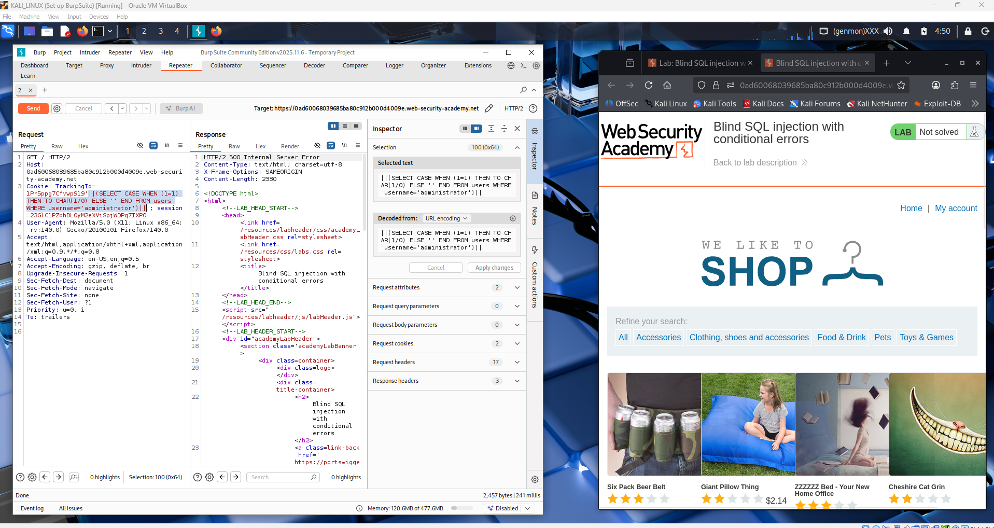

A conditional SQL payload using CASE WHEN is injected into the TrackingId cookie in Burp Repeater. When the condition evaluates to true, the query executes 1/0, which triggers a 500 Internal Server Error, confirming that the injected SQL condition is processed by the database and can be used to extract information during the blind SQL injection attack.
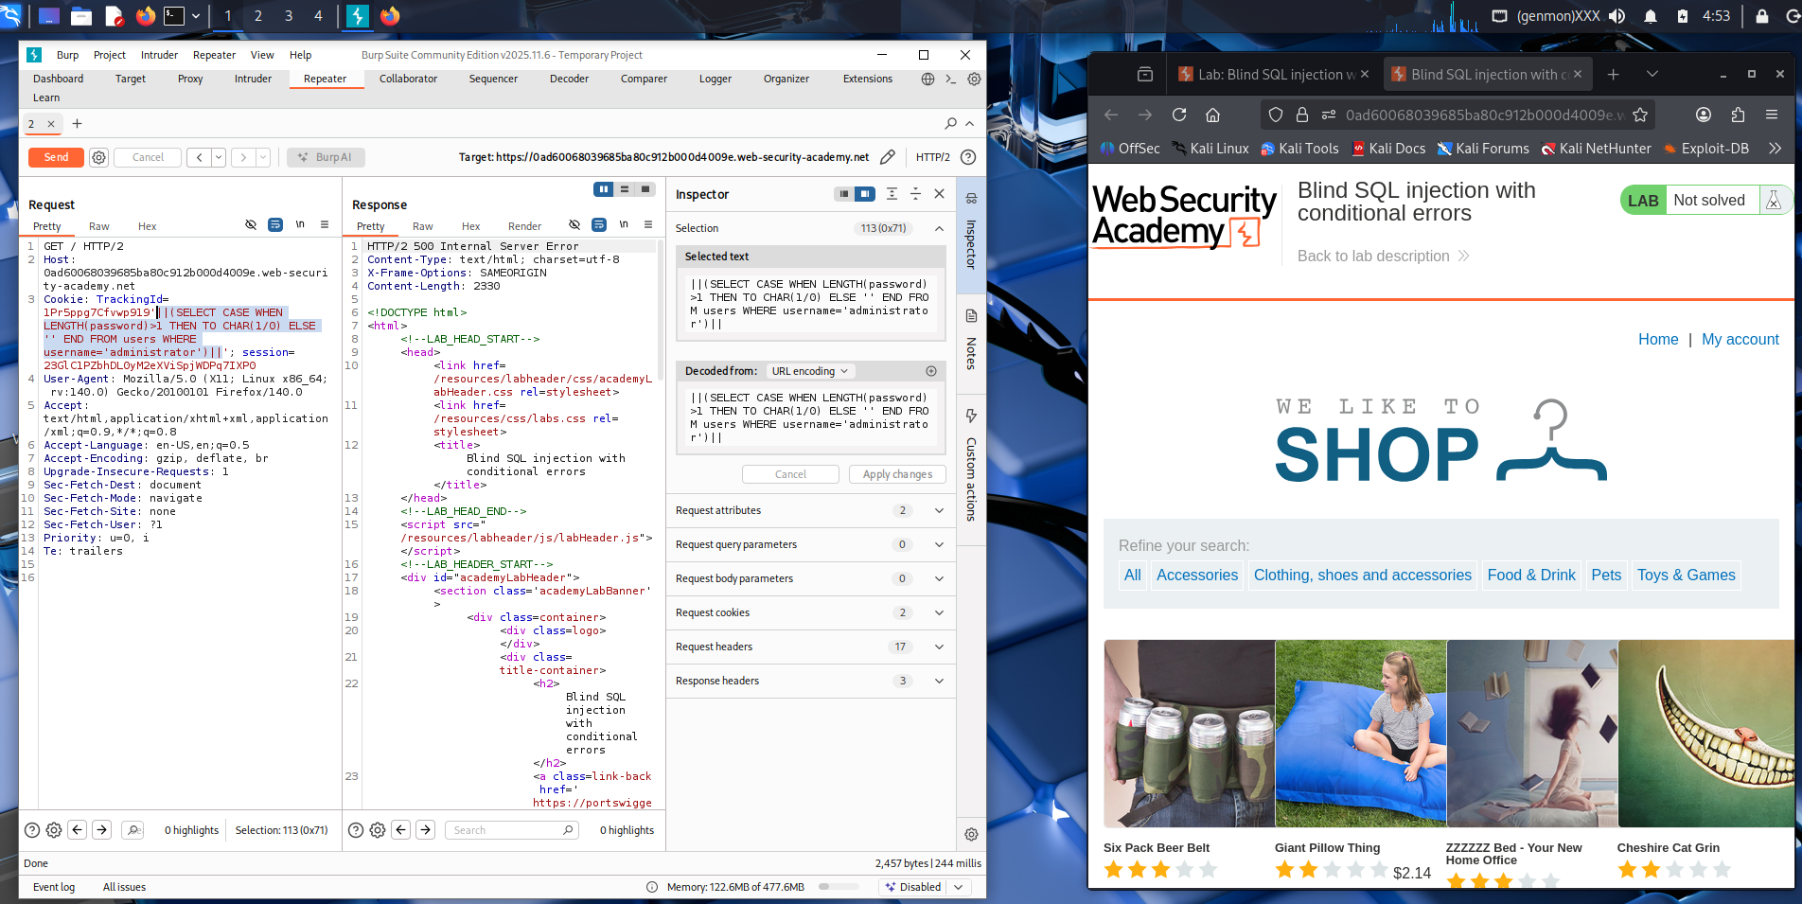

Burp Suite Intruder is used with a Sniper attack to automatically test multiple payloads. A sequence of numbers is configured as payloads to iterate through possible values (such as password length or character position), allowing the attacker to identify correct conditions based on the server’s response during the blind SQL injection process.
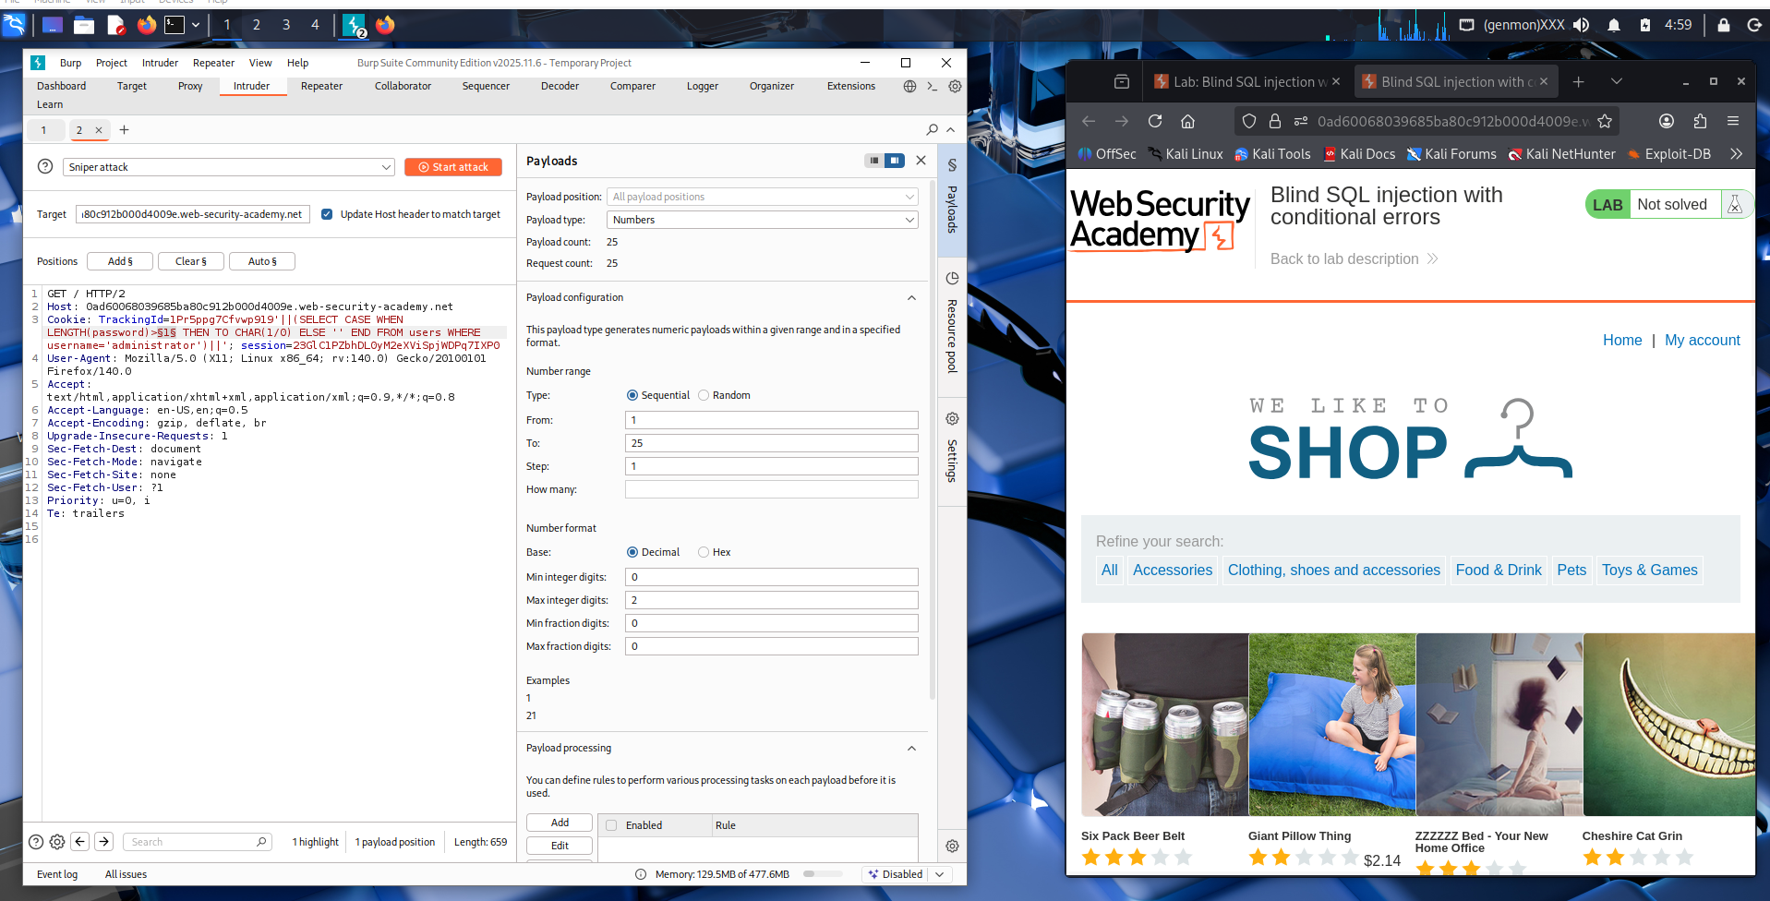

Burp Suite Intruder sends multiple payloads to the vulnerable parameter to test different values automatically. The responses show HTTP 500 Internal Server Error, indicating that the injected condition triggers a database error. By analyzing which payloads cause errors, the attacker can infer correct information during the blind SQL injection with conditional errors process.
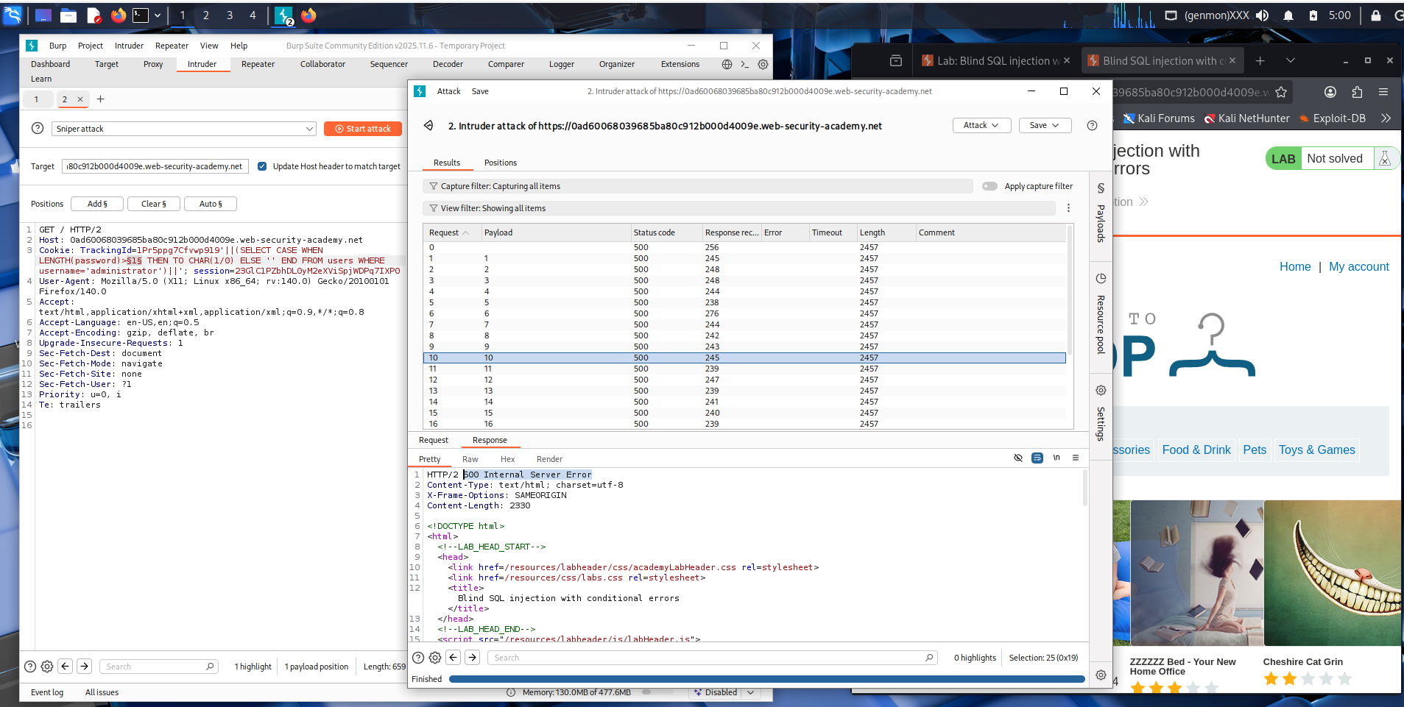

In this step, Burp Suite Intruder is used to perform a brute-force attack on the vulnerable parameter in the cookie. The payload type is set to Brute force, and a list of characters (letters and numbers) is used to test different values. Intruder automatically sends multiple requests with different payloads to the server.
In the Results section, each request returns a 500 Internal Server Error, which indicates that the injected payload triggers a database error. This behavior confirms that the application is vulnerable to Blind SQL Injection with conditional errors, and the attacker can use these errors to extract information from the database step by step.
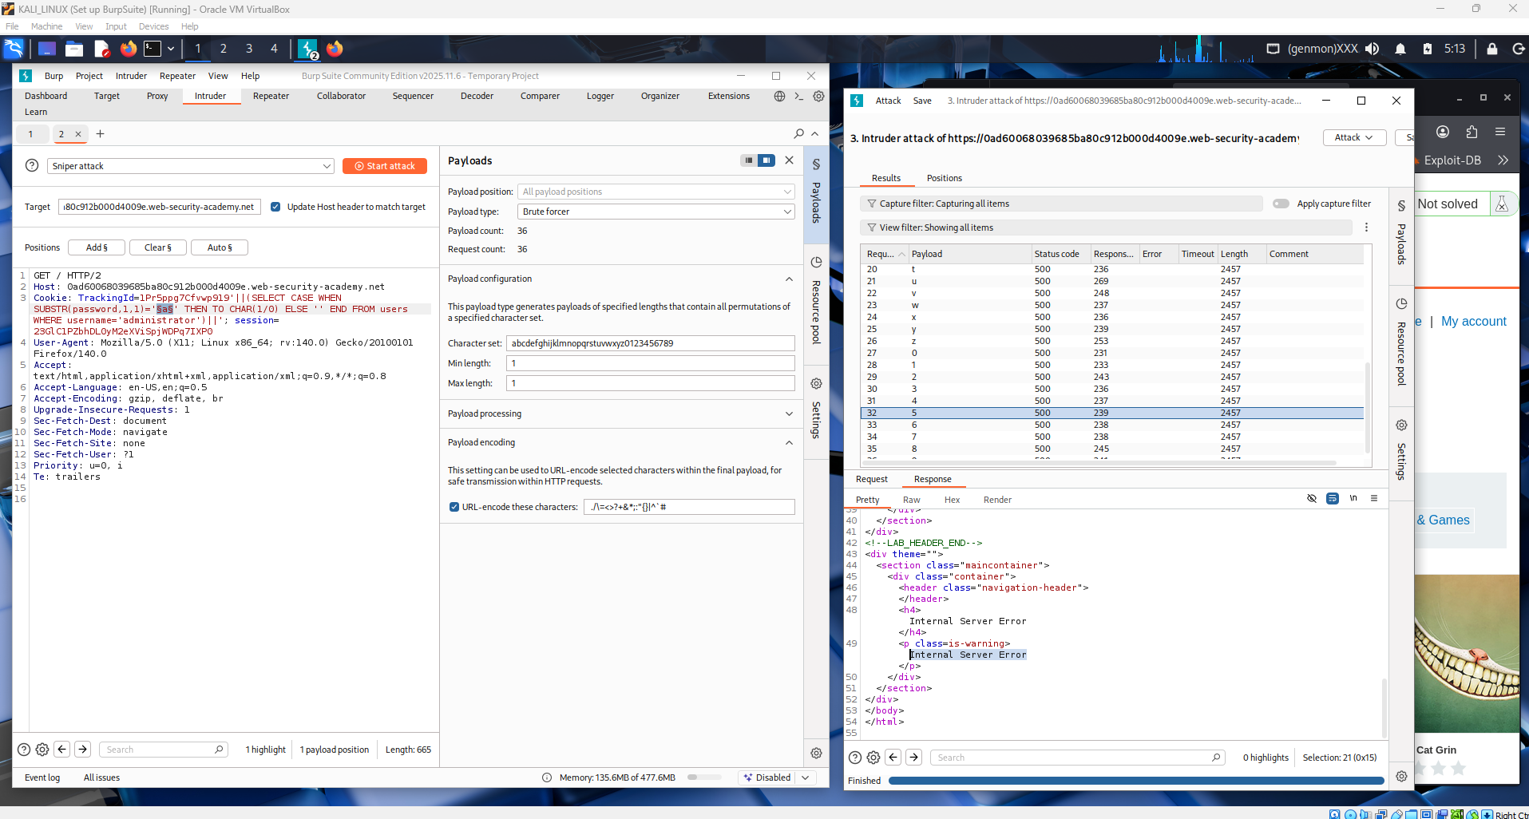

In this step, the SQL injection payload is inserted into the cookie parameter and sent through Burp Suite Intruder. A brute-force payload list containing lowercase letters and numbers is used to test possible characters of the administrator password. Each payload is processed by the server, and the responses are displayed in the Intruder results panel. When the injected condition causes a database error, the server returns a 500 Internal Server Error, indicating that the tested character is likely correct for that position in the password. By analyzing these responses, the attacker can gradually determine each character of the administrator’s password.
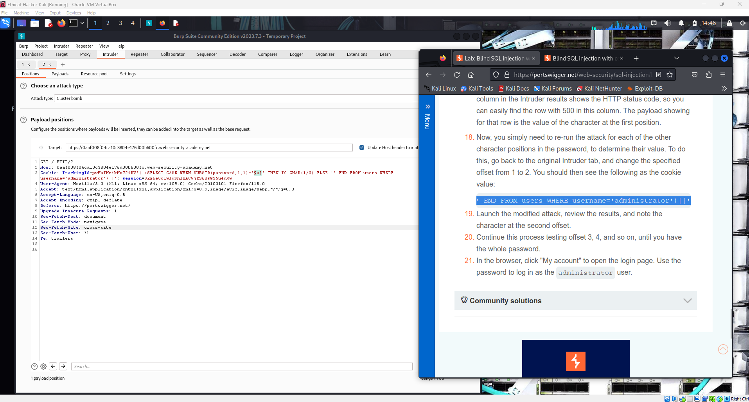

In this step, Burp Suite Intruder is configured to test possible characters for one position of the administrator password. A simple payload list containing letters and numbers is added so that each character can be tested individually. When the attack is launched, Intruder sends multiple requests to the server with different characters inserted into the SQL injection payload.
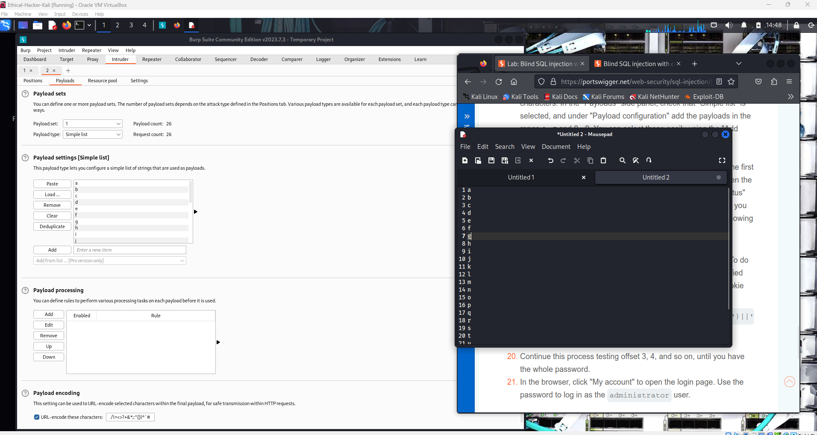

Burp Intruder is sending different payloads (characters) to the target application. The responses all return HTTP status code 200, but the response statuscode is different, which indicates that one of the tested characters produces a different server response. By comparing these responses, it is possible to determine the correct character of the administrator’s password step by step.
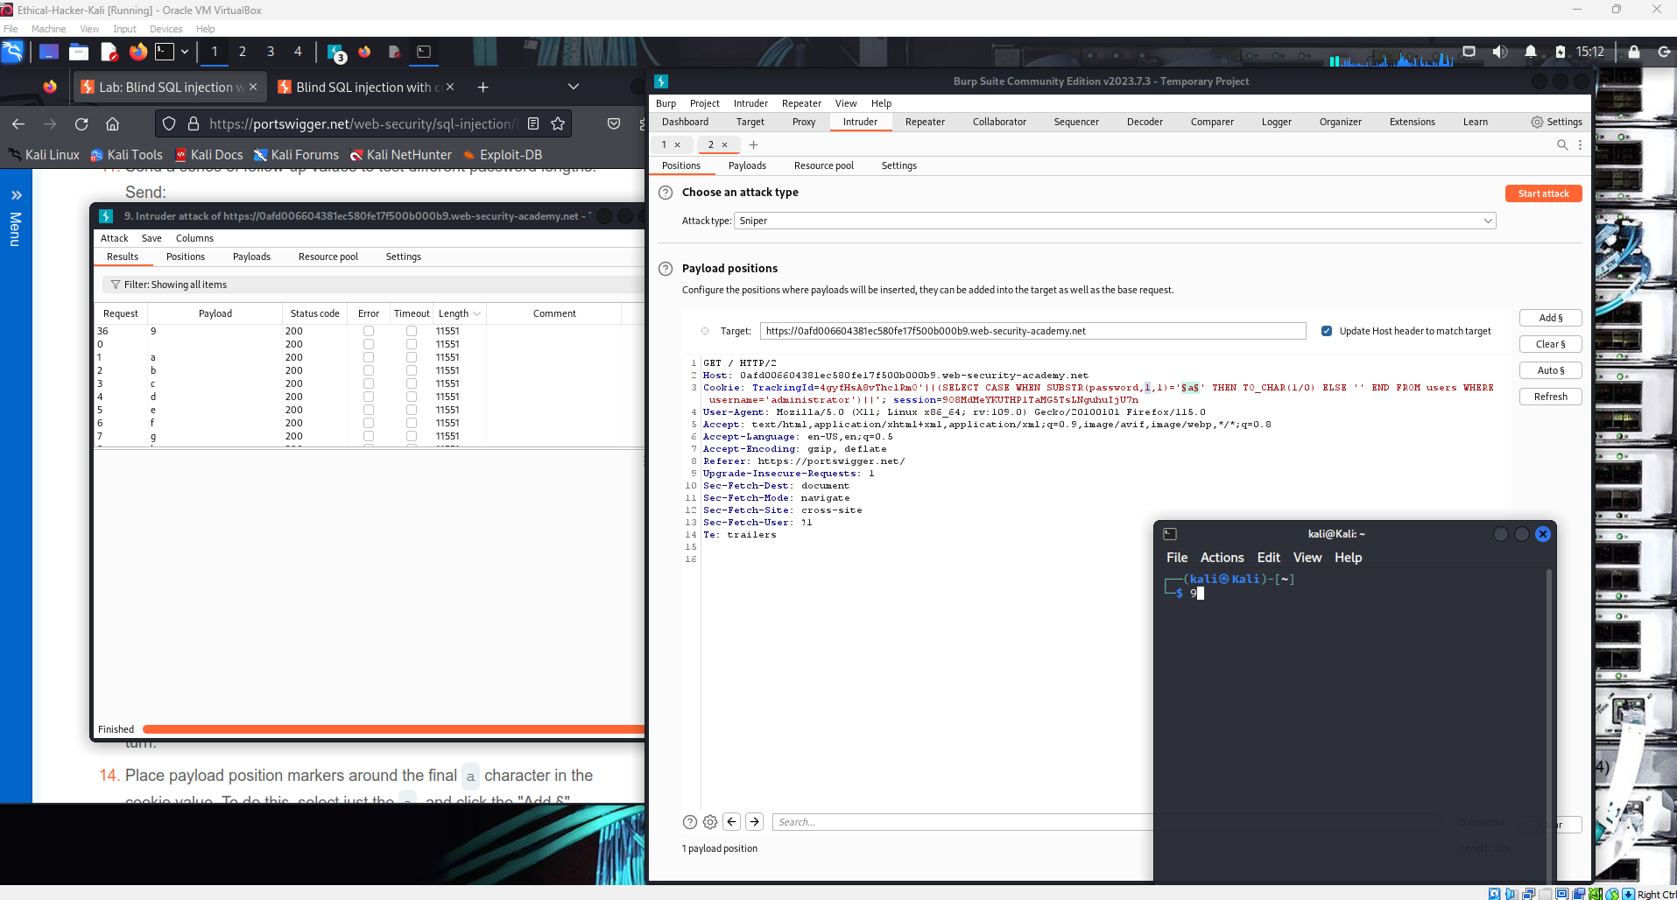

Burp Suite Intruder is sending multiple payloads to test the SQL injection point in the request. One payload causes a 500 Internal Server Error, which suggests the input may be affecting the SQL query. This difference in response helps identify a possible SQL injection vulnerability.
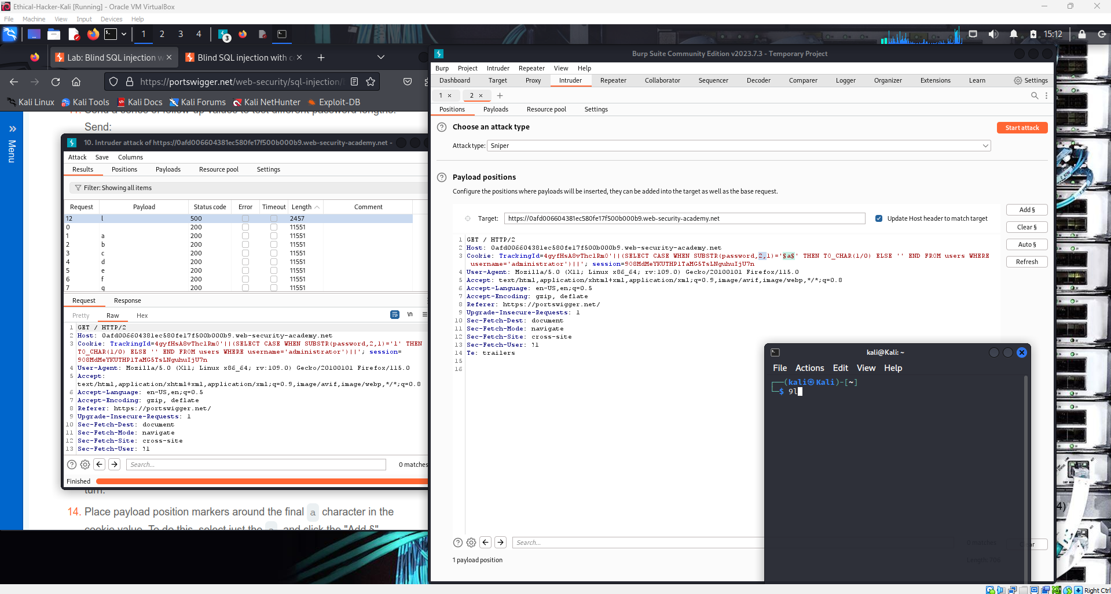

The results show different response lengths when testing each payload in Burp Suite Intruder. One request returned a different status code (500) and shorter length, indicating the payload triggered a database error. This difference suggests the injected character affects the SQL query, helping identify the correct character during the Blind SQL Injection process.
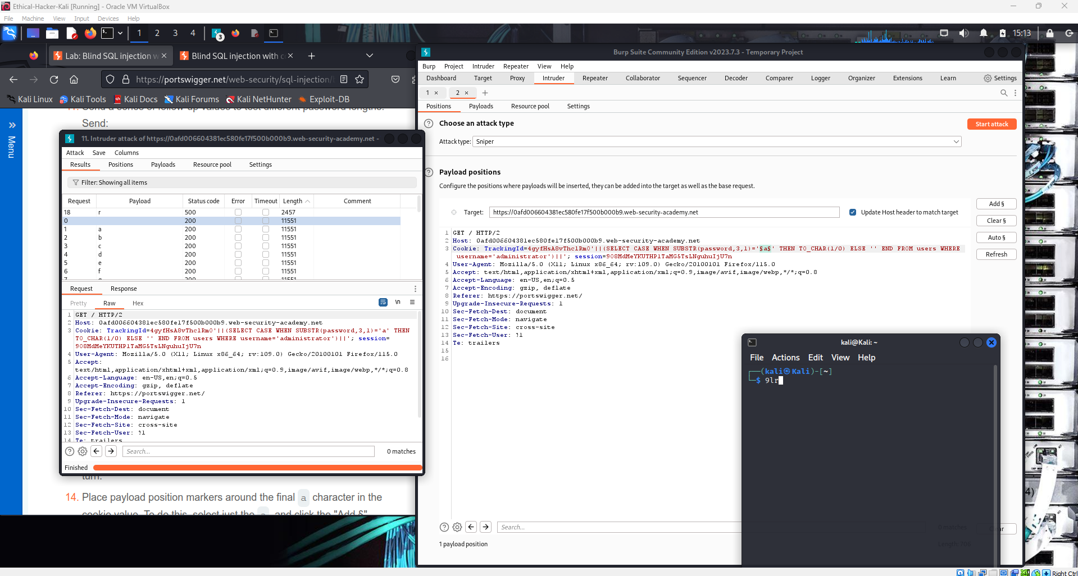

This screenshot shows Burp Suite Intruder performing a Blind SQL Injection test. The tool sends different characters as payloads to the server to see how the response changes. By checking the HTTP status codes and responses, the tester can identify which character is correct in the database query.
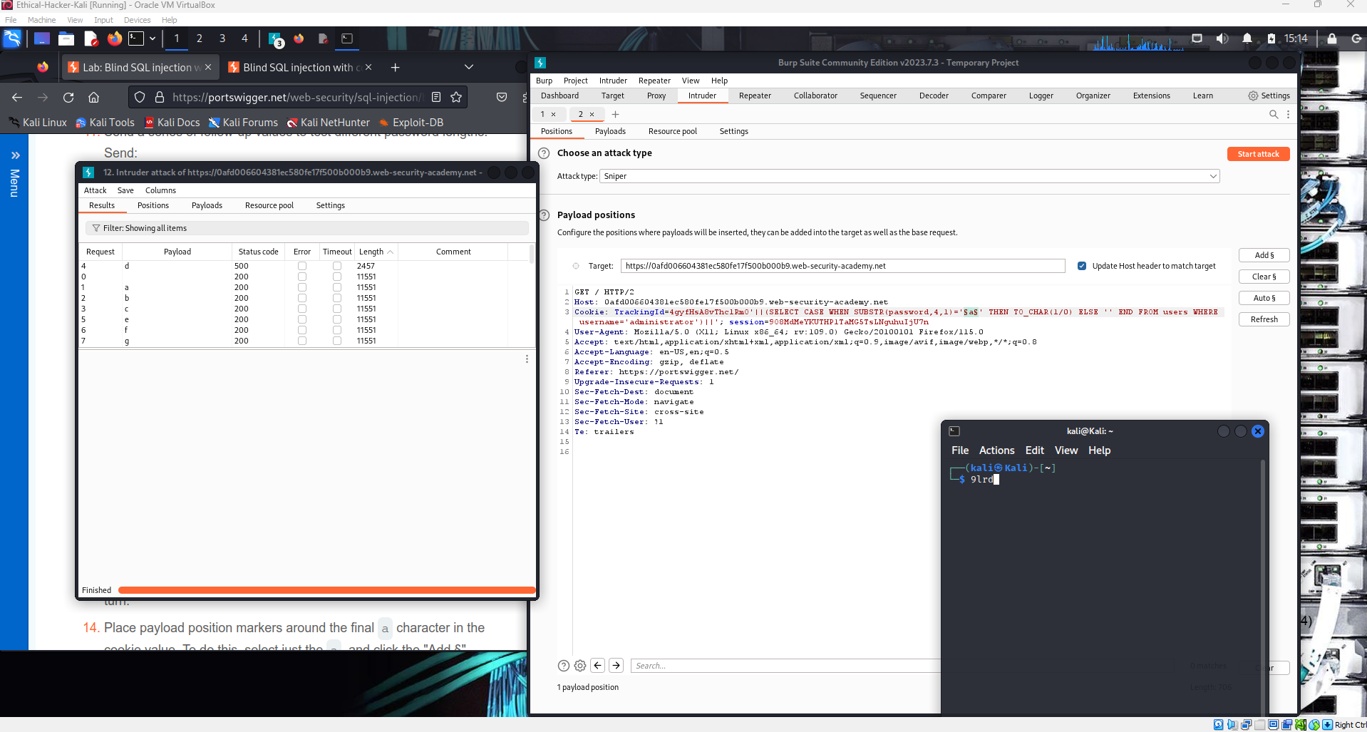

This step explains how to continue the Blind SQL Injection attack to extract the password.
After identifying the correct character for the first position (based on the HTTP 500 status code), you repeat the attack for the next positions by changing the offset value (1 → 2 → 3, etc.). By doing this, you can gradually discover each character until the full administrator password is obtained.
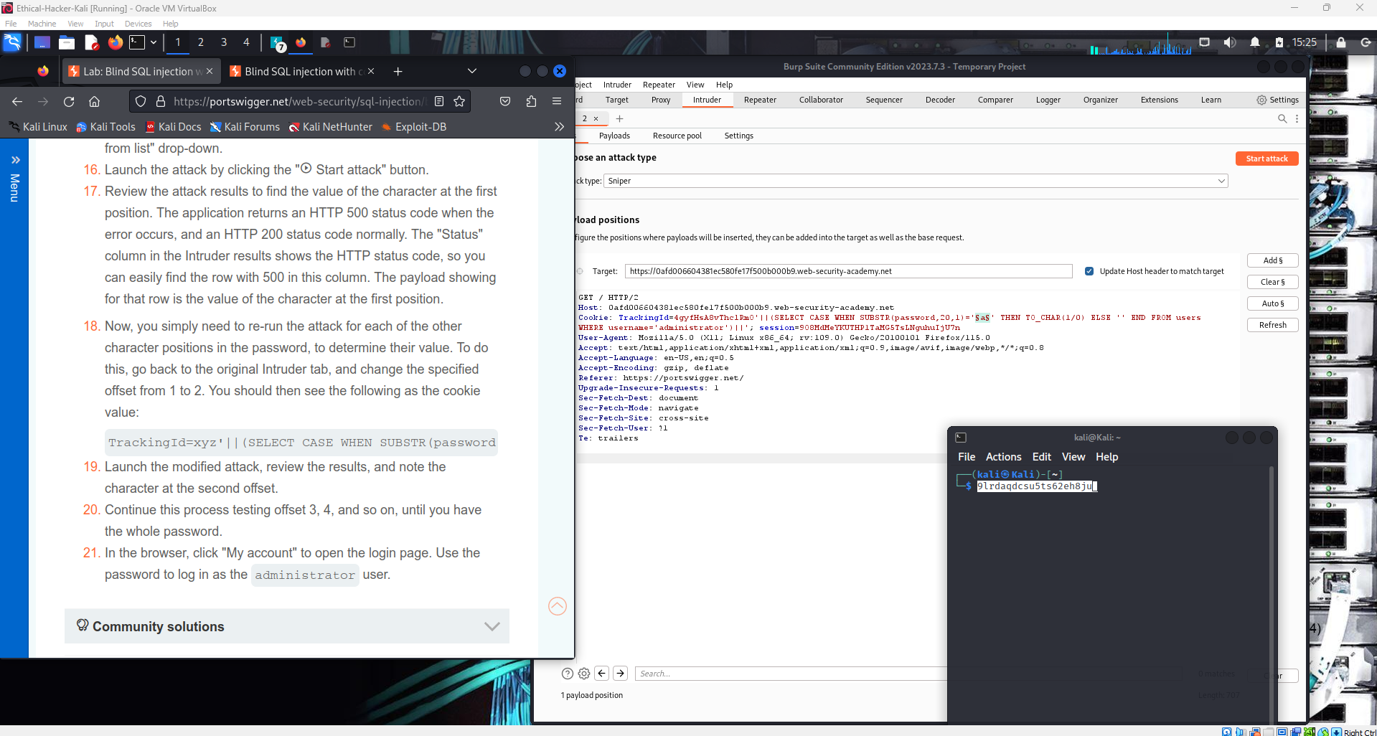

This screenshot shows that the Blind SQL Injection attack was successful. The attacker extracted the administrator password using Burp Suite Intruder, then logged in to the account, which solved the lab.
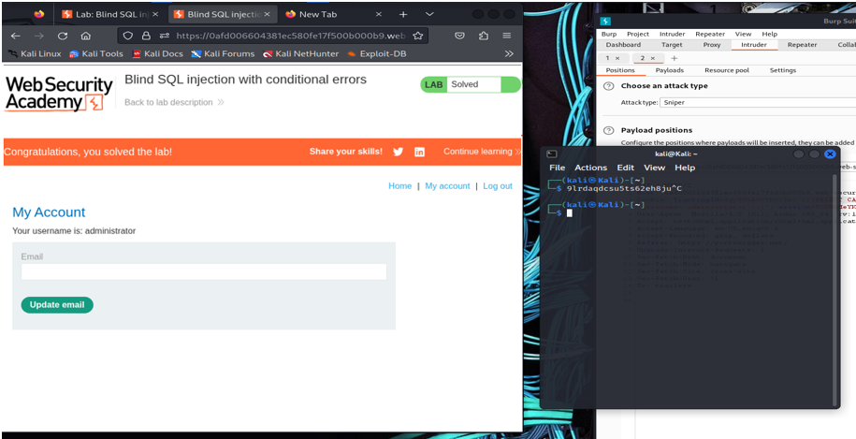

1. What is an Error-Based SQL Injection attack, and how does it differ from other types of SQL injection?
Error-Based SQL Injection is a technique in which an attacker deliberately triggers database error messages in order to obtain information about the database structure, queries, or stored data. When the application displays detailed error messages, attackers can analyze these responses to understand how the backend database processes SQL queries.
In this type of attack, malicious SQL statements are inserted into input fields, URL parameters, or cookies. If the database encounters an error while processing the injected query, the application may return a message containing valuable information such as:
- database type
- table names
- column names
- query structure
- sensitive data
For example, an attacker may insert a payload that causes a division by zero error or an invalid query. If the error message is returned to the user, the attacker can use that feedback to refine further attacks.
Difference between Error-Based SQL Injection and other SQL Injection types:
Type | Description
Error-Based SQL Injection | Uses database error messages to extract information directly from the database.
Union-Based SQL Injection | Uses the SQL UNION operator to combine attacker queries with legitimate queries to retrieve data.
Blind SQL Injection | Occurs when the application does not display database errors, forcing attackers to infer information based on response behavior.
Time-Based SQL Injection | Uses time delays in the database response to determine whether conditions are true or false.
Compared to other SQL injection types, Error-Based SQL Injection is easier and faster because the database itself reveals useful information through error messages.
2. Explain the concept of using database errors to extract information
Using database errors to extract information means that attackers intentionally create invalid SQL queries to force the database to produce error responses. These error messages may reveal important internal details about the system.
For example, an attacker might inject:
' OR 1=1--
or deliberately trigger an error such as:
1/0
which produces a division by zero error.
By observing how the web application reacts to these errors, attackers can gradually determine:
- the database management system (MySQL, Oracle, PostgreSQL, etc.)
- the structure of the database
- the names of tables and columns
- whether certain data exists
Attackers then refine their SQL payloads to retrieve sensitive data such as usernames and passwords.
Typical signs that a web application is vulnerable
A web application may be vulnerable to error-based SQL injection if it shows:
- Database error messages
  - Example:
SQL syntax error
ORA-01756
MySQL syntax error near...
- Different responses after adding special characters
  - Example: entering ' causes the page to crash or display an error.
- Unexpected server responses
  - HTTP 500 errors after specific inputs.
- Database-specific messages
  - Oracle errors
  - MySQL errors
  - PostgreSQL errors
These indicators suggest that the application is processing user input directly in SQL queries without proper validation or parameterized queries.

3. Challenge: Blind SQL Injection with Conditional Errors
This challenge demonstrates a Blind SQL Injection attack using conditional database errors. The attacker extracts sensitive information by triggering database errors only when certain conditions are true.
The goal of the challenge is to retrieve the password of the administrator user.
The testing process was performed using Burp Suite from the PortSwigger lab environment.

4. Steps to perform the attack
Step 1 – Identify SQL injection vulnerability
Modify the TrackingId cookie:
TrackingId=xyz'
This creates a SQL syntax error
If the application response changes or returns an error, it indicates that SQL injection may be possible.

Step 2 – Test valid SQL query
Submit:
TrackingId=xyz'||(SELECT '')||'
If the query is invalid, it may indicate the use of Oracle database, which requires a table name in SELECT.

Step 3 – Confirm Oracle database
Use the Oracle system table:
TrackingId=xyz'||(SELECT '' FROM dual)||'
If no error appears, it confirms the database is likely Oracle.

Step 4 – Verify the users table exists
TrackingId=xyz'||(SELECT '' FROM users WHERE ROWNUM=1)||'
If no error occurs, the users table exists.

Step 5 – Trigger conditional error
TrackingId=xyz'||(SELECT CASE WHEN (1=1) THEN TO_CHAR(1/0) ELSE '' END FROM dual)||'
Explanation:
- 1/0 → division by zero → database error
- Error only occurs when the condition is true

Step 6 – Check administrator user
TrackingId=xyz'||(SELECT CASE WHEN (1=1) THEN TO_CHAR(1/0) ELSE '' END FROM users WHERE username='administrator')||'
If an error appears, the administrator user exists.

Step 7 – Determine password length
TrackingId=xyz'||(SELECT CASE WHEN LENGTH(password)>10 THEN TO_CHAR(1/0) ELSE '' END FROM users WHERE username='administrator')||'
Repeat with different numbers until the error stops appearing.
Result:
Password length = 20 characters

Step 8 – Extract password characters
Use:
SUBSTR(password,1,1)
Example:
TrackingId=xyz'||(SELECT CASE WHEN SUBSTR(password,1,1)='a' THEN TO_CHAR(1/0) ELSE '' END FROM users WHERE username='administrator')||'
If the condition is true → HTTP 500 error appears.

Step 9 – Automate attack with Burp Intruder
Use Burp Intruder to test all characters:
Payload list:
a-z
1-9
The correct character will produce HTTP 500 status.

Step 10 – Repeat for each position
Change:
SUBSTR(password,1,1)
to
SUBSTR(password,2,1)
SUBSTR(password,3,1)
SUBSTR(password,4,1)
Continue until all 20 characters are discovered.

Step 11 – Login as administrator
Use the extracted password to log in to the application as:
username: administrator
password: extracted_password
This completes the challenge.

Conclusion
This lab demonstrated how Blind SQL Injection with conditional errors can be used to extract sensitive information from a vulnerable web application. By manipulating the TrackingId cookie and injecting specially crafted SQL queries, it was possible to trigger database errors only when certain conditions were true.
Through this method, the attacker was able to confirm the existence of the users table, identify the administrator account, determine the length of the password, and eventually extract the password character by character. The attack was automated using Burp Suite Intruder, which allowed testing multiple payloads efficiently. The challenge environment provided by PortSwigger clearly illustrates how attackers can exploit application responses to infer hidden data even when direct query results are not displayed.
This exercise highlights the importance of secure coding practices. Developers should prevent SQL injection vulnerabilities by using parameterized queries, prepared statements, proper input validation, and disabling detailed database error messages. Implementing these security measures can significantly reduce the risk of attackers exploiting SQL injection vulnerabilities to access sensitive information.

